Three phase four wire smart meter

Instruction

Brief of products

General
This is an advanced smart meter in the world. It is adopt large scale integrated circuit board and SMT technology to produce. It is tailored to ECG specification and mimic ECG’s tariff.
  - Features
窗体底端
- It is W-embedded high-speed and precision A/C V/A acquisition module with high accuracy, accurate and real-time measurement;
窗体顶端
- It measures active and reactive power, stores the data. It communicate with RS485 and infrared;
It hasIII窗体底端
窗体顶端
- It has an excellent compatibility of electromagnetic, is able to withstand the interference of high voltage spikes, strong magnetic fields, strong static electricity and lightning surges, and has a strong range of temperature adaptability;
窗体底端
窗体顶端
- It has three-phase power supply interdependently and works properly even any a single phase on;
iI窗体底端
窗体顶端
- It Built-in backup battery power, the clock will work 10 years without outside power supply;
2. Specification
  - Voltage: 230/400V x 3
  - Current: (10)100A x 3
  - Frequency： 50Hz
  - Accuracy: 1.0 class
  - Start current： 0.002In (1.0)
  - Creep： Anti-creep
- Electronic specification：
Normal voltage | 0.8Un～1.1Un
Abnormal voltage | 0.7Un～1.2Un
Consumption | ≤ 2W/8VA
Voltage of clock | 3.0V_{DC}
- Data：
Clock error (Day) | ≤0.5S (23℃)
Battery | ≥1000mAh
Data keeping | ≥10Years (New battery)
- Climate：
Working temp | -25℃～+60℃
Extreme temp | -40℃～+70℃
Stock and convey | -40℃～+70℃
Humidity | ≤85%
- Communication：
Display | Crystal
Communication | RS485： 2400bps  Infrared：1200bps
Protocol | 《DL/T645–2007》

3. Working principal
It is formed with measuring unit and processing unit to measure and compete the power consumption. It can display the information of meter, store and output the data.

Diagram 1：

A/C V/A
Module
CPU
LCD
I_{A} I_{B} I_{C}
Memory
GPRS
Pulse
PC
RS-485
V_{A} V_{B} V_{C}
Lap top
Infrared
Hand Set
Warning
Power supply
Power
management
Battery
V_{A} V_{B} V_{C}

When meter works, the module takes the samples voltage and current from loop to compete and process, then send to CPU for smart control. The processed data will be stored in the memory and be sending out by LCD and by interface of RS 485, GPRS and infrared.
4. Installation and measurement

4.1 Out look
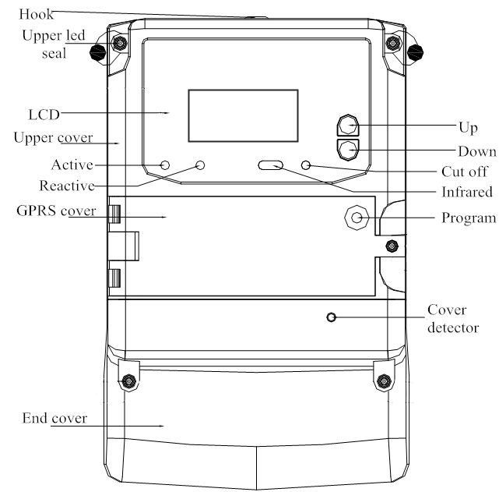

Diagram 2

4.2 LCD Displays
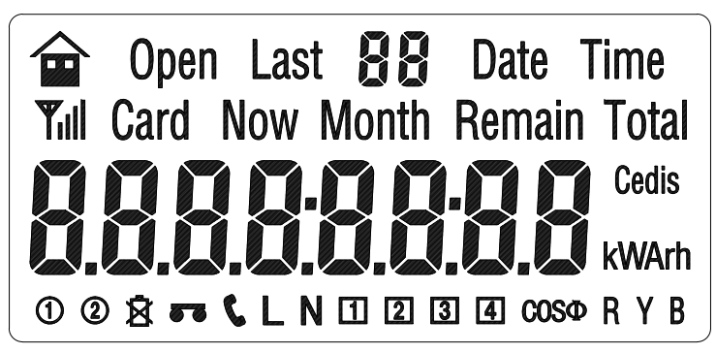

Explanation
Symbol | Indication
kW h | kWh—Active power kW—Active demand
kV Arh | kvarh—Reactive power kvar—Reactive demand
VA | V—Voltage A—Current
COSΦ | Power factor
Cedis | Money
 | RS-485
 | Battery statue
 | Permission to program
 | GPRS
 | In factory mode
 | Currently tariff table applied
 | Phase A, B, C
 | Currently block of tariff applied, if more than 4 will be 1 + 4=5，2 + 4=6，3 + 4=7，1 + 3 + 4=8，2 + 3 + 4=9
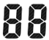 | Serious No.
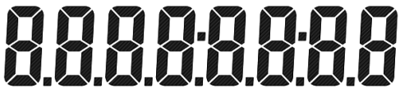 | Figure

4.3 Installation and wiring
4.3.1 Meter should be installed at a safe, clean, air pass and dry place. It is will be in the meter enclosure. The height of meter should not allow the children to reach.
4.3.2 There is a hole on the upper side of meter for fixing screw to pass and hang the meter. There are two holes down for screw to fix the meter.

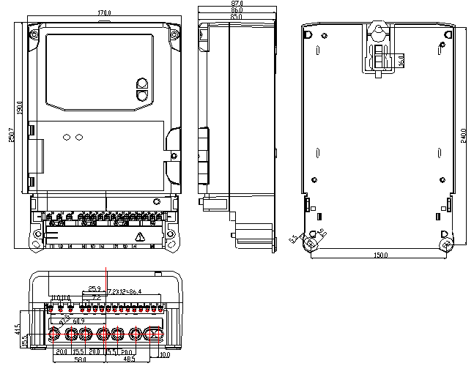
Diagram 3.
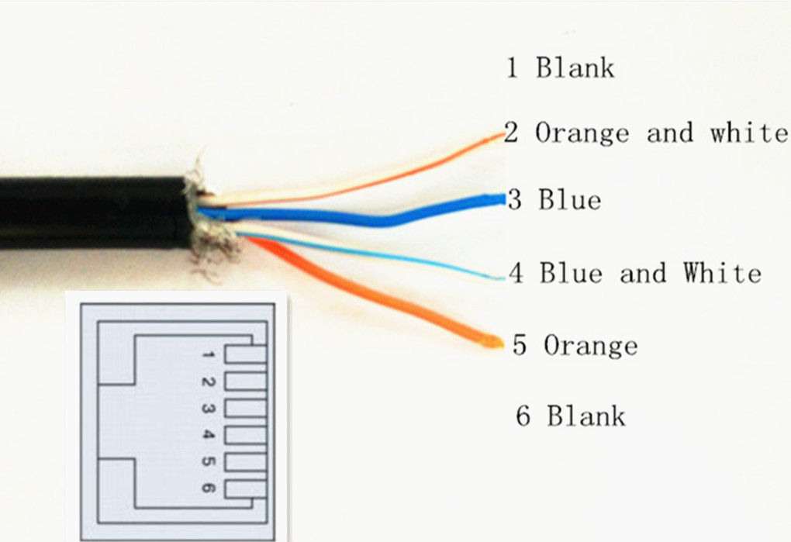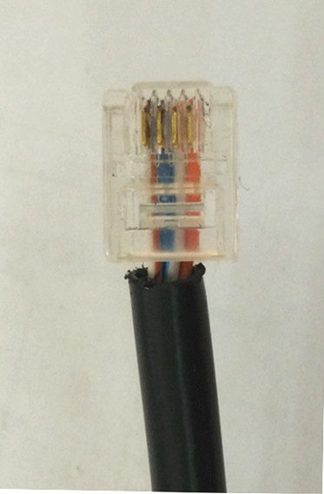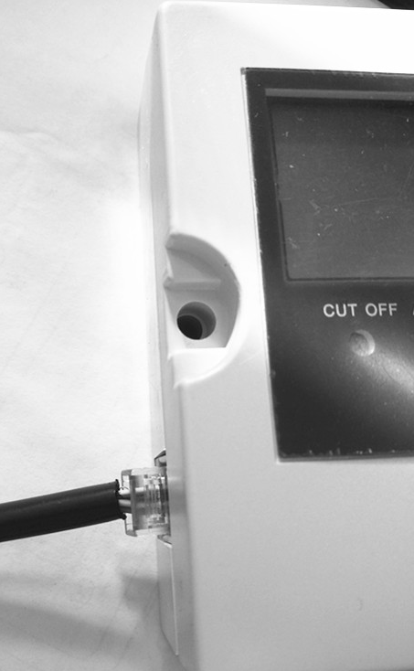

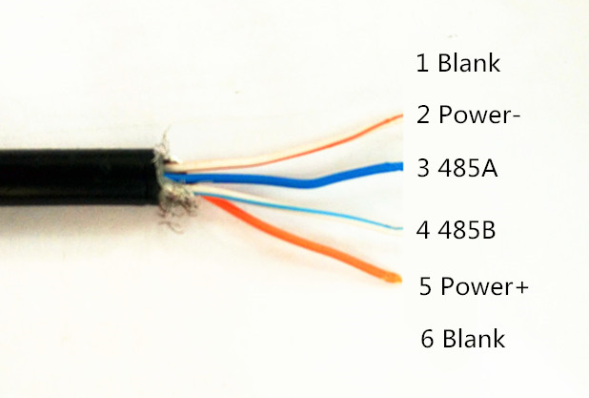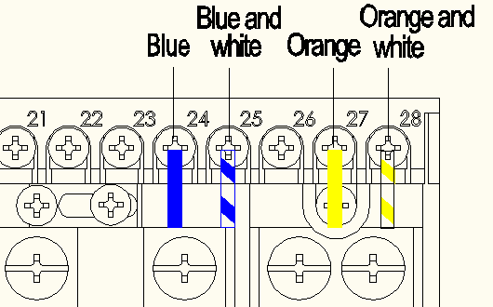
Diagram 4.

4.3.3 The wiring of the meter should follow the instruction and fastened the screw tightly. Loose contact will be causing the high temperature, even fire.
4.3.4 Wiring diagram (Please look at the back side of cover)
1) Functions Wiring (Connection)
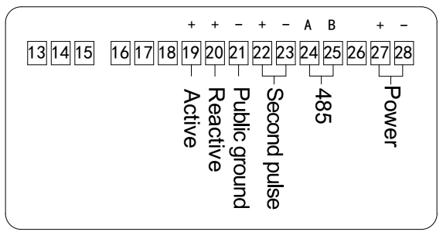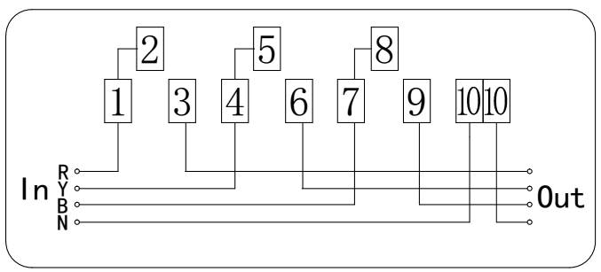

5. Basic functions
5.1 Record of maximum demand
Maximum demand- It is measured by the meter with highest average power demand in a certain period.
Demand period- The interval of measurement, mostly is 15 min.
Slip time- Every 1 min. will the slip time of demand period.

Record of maximum demand
Name | Detail
Active maximum demand value and time of happened | Currently, last day~last 12 days maximum demand and time of happened.

Settlement of Power and maximum demand: It can be settled in the first 1~3 day of the natural month. When the time is due, the data will be stored in the meter and current value will be reset to zero.

5.2 Auto scroll display mode and button display mode

Auto scroll display mode. Every display will be in screen for 5 min., and then scroll to next.
It is can be in button display as well. Press the button on the meter, it will enter button display mode, you can get the what you want to see. Press button Up or Down, it will scroll the figure. If it is idle for 20 sec., the display will change to auto scroll display mode again.

 | Information
S No | Indication | Code | Button display | Auto display | Power off | Technician
1 | Error |  | ● | ●
2 | Date | 13 + Now + Date | ● | ● | ●
3 | Time | 14 + Now + Time | ● | ● | ●
4 | Lower 8 digit of meter No. | 15 | ● |  | ●
5 | Higher 4 digit of meter No. | 16 | ● |  | ●
6 | Lower 8 digit of customer ID | 17 | ●
7 | Higher 4 digit of customer ID | 18 | ●
8 | Money left | 19 + Now + Remain + Cedis | ● | ● | ●
9 | Current consumption in kWh | 20 + Now + Month + kWh | ● | ● | ●
10 | Current charge in Cedis | 21 + Now + Month + Cedis | ● | ●
11 | Accumulate consumption in kWh | 22 + Now + Total + kWh | ● |  | ●
12 | Accumulate charges in Cedis | 23 + Now + Total + Cedis | ●
13 | A,B,C Voltage | 24 + Now + V | ●
14 | A,B,C Current | 25 + Now + L + A | ●
15 | A,B,C Power | 27 + Now + kW | ●
16 | Maximum demand happened date | 28 + Date | ●
17 | Maximum demand happened time | 29 + Time | ●
18 | Maximum demand value | 30 + kW | ●
19 | Consumption of last day | 31 + Last + kWh | ●
20 | Charge of last day | 32 + Last + Cedis | ●
21 | Days left for use | 33 + Remain | ●
22 | Over voltage limit set | 34 + V |  |  |  | ●
23 | Over current limit set | 35 + A |  |  |  | ●
24 | Over lord limit set | 36 + kW |  |  |  | ●
25 | Display warning | 37 + Cedis |  |  |  | ●
26 | Cut off warning | 38 + Cedis |  |  |  | ●
27 | Version No. | 39 |  |  |  | ●
28 | Counter of temper meter | 40 |  |  |  | ●
29 | Counter of cut off | 41 |  |  |  | ●
30 | Counter of illegal card | 42 |  |  |  | ●
31 | Counter of power supply off | 43 |  |  |  | ●
32 | Over consumption | 44 + Cedis |  |  |  | ●
33 | Consumption of last month | Last + 01 + Month + kWh | ● | ●
34 | Charge of last month | Last + 01 + Month + Cedis | ● | ●
35 | Consumption of last 2nd month | Last + 02 + Month + kWh | ●
36 | Charge of last 2nd month | Last + 02 + Month + Cedis | ●
37 | Consumption of last 3rd month | Last + 03 + Month + kWh | ●
38 | Charge of last 3rd month | Last + 03 + Month + Cedis | ●
39 | Consumption of last 4th month | Last + 04 + Month + kWh | ●
40 | Charge of last 4th month | Last + 04 + Month + Cedis | ●
41 | Consumption of last 5th month | Last + 05 + Month + kWh | ●
42 | Charge of last 5th month | Last + 05 + Month + Cedis | ●
43 | Consumption of last 6th month | Last + 06 + Month + kWh | ●
44 | Charge of last 6th month | Last + 06 + Month + Cedis | ●
45 | Consumption of last 7th month | Last + 07 + Month + kWh | ●
46 | Charge of last 7th month | Last + 07 + Month + Cedis | ●
47 | Consumption of last 8th month | Last + 08 + Month + kWh | ●
48 | Charge of last 8th month | Last + 08 + Month + Cedis | ●
49 | Consumption of last 9th month | Last + 09 + Month + kWh | ●
50 | Charge of last 9th month | Last + 09 + Month + Cedis | ●
51 | Consumption of last 10th month | Last + 10 + Month + kWh | ●
52 | Charge of last 10th month | Last + 10 + Month + Cedis | ●
53 | Consumption of last 11th month | Last + 11 + Month + kWh | ●
54 | Charge of last 11th month | Last + 11 + Month + Cedis | ●
55 | Consumption of last 12th month | Last + 12 + Month + kWh | ●
56 | Charge of last 12th month | Last + 12 + Month + Cedis | ●

5.3 Records of power supply off
It is recorded as power supply off only if when all the three phases of A.B.C. are off. It keeps last ten events of power supply off and on. Records includes the time of power supply off and time of power supply on.

5.4 Warning display
When following faults happens, faulty code will remain in the screen for a long time., and then the background light goes off and waits for technician form ECG to come and handle.
Bit7 | Bit6 | Bit5 | Bit4 | Bit3 | Bit2 | Bit1 | Bit0
Reserve | Reserve | Esam Error  0-No  1-Yes | Clock Error  0-No  1-Yes | Reserve | Battery weak  0-No  1-Yes | EEPROM Error  0-No  1-Yes | Relay Faulty  0-No  1-Yes
Bit15 | Bit14 | Bit13 | Bit12 | Bit11 | Bit10 | Bit9 | Bit8
Reserve | Flag of over current  0-No  1-Yes | Flag of open cover  0-No  1-Yes | Flag of over power  0-No  1-Yes | Reserve | Flag of over voltage  0-No  1-Yes | Current reverse  0-No  1-Yes | Current unbalance  0-No  1-Yes

5.5 Programming
Permission to program: Open the GPRS cover by an authorized person and press the programming button, the sign of will show on the screen, meter is ready to program.
Forbidden to program: Press the same button again and sign will go off. It is forbidden to program of the meter.
Address of communication: Address has to be entered before any equipment communication to the meter. It is only ID to commute to meter with any equipment.
5.6 RS-485 and GPRS communication
Apart from RS-485 interface to commute with meter, other options like GPRS or infrared are also provided to do so. The baud rate for GPRS and RS485 is 2400bps and for infrared is 1200bps.
5.7 Event clear function
There are tow clear functions, one is over all clearance and one is single event clearance. Single event clearance can be used for clear records of Power-off , records of Programming, records of Temper meter. Some records can be only cleared in statues of production jointly by permission to program such as records of Event clearance, records of Meter reset and records of Consumption.

5.8 Anti-temper of meter
Bit8 | Bit6 | Bit5 | Bit4 | Bit2 | Bit1 | Bit0
Magnetic field  0 No  1 Yes | Current is 0 in live line 0 No  1 Yes | Unbalance of current  0 No  1 Yes | Phase line lost  0 No  1 Yes | Current reverse  0 No  1 Yes | Open top cover  0 No  1 Yes | Open wire cover  0 No  1 Yes

When Bit0，Bit1，Bit8is is Yes, the meter will cut off the power supply to the customer to prevent further damage to the meter and been recorded. Other Bits Yes, only been recorded but not cut off.

5.9 Other features

1-50 records of purchase include date, purchase amount, money left before purchase, amount after top up and totally purchase times.

Last 2 records of cut off by meter (Code + time of cut off + time of resume power supply by top up)

1-100 records of temper of meter.

1-100 records of illegal cards ( Time + type of cards + serious No.)

1-100 records of power supply off (time of started + time of resumed)
- 100 days in every 15 min. Load profile

6. Code of using smart card
Amount changed | Top up success
IC-PASS | Operation success
IC-0001 | Meter No. error
IC-0002 | Customer ID error
IC-0004 | Purchase times not match
IC-0008 | Card No. error
IC-0010 | Over top up
IC-0020 | Card is invalid
IC-0040 | Authenticate fail
IC-0080 | Re top up
IC-0100 | Meter in use, not for testing card
IC-0200 | Illegal card
IC-0400 | Open account fail or account is exist
IC-1000 | Temper clear card has been used
IC-2000 | Data format illegal or card damage
IC-4000 | Amount deducted more than amount left
IC-8000 | No account in the meter (Purchase times is 0)

7. Transportation and storage
窗体顶端
- Products in the transport and unpacking should not be violent impact, and in accordance with GB / T15464-1995 "General Instrument Packaging technical" provisions of transport and storage
窗体底端
窗体顶端
- Stock and storage should be stored in the original packaging conditions, the stack height should not exceed 5 layers
窗体顶端
- Storage should be clean, the ambient temperature should be 0 ~ 40 ℃, relative humidity less than 85%, and in the air does not contain enough to cause corrosion of harmful substances.

8. After sale service
窗体顶端
- Meter within 18 months from the date of sale, factory intact seal and the user to comply with the requirements of the manual, found that the meter does not meet the national standard GB / T17215-2008 requirements, the manufacturer to give free repair or replacement, 18 months to 5 years, the manufacturer to ensure repair, but the cost of nuclear revenue.

窗体底端

